David Winter
Storyteller Viewer Advocate Journalist
949-500-4027 davidmaxwellwinter@gmail.com

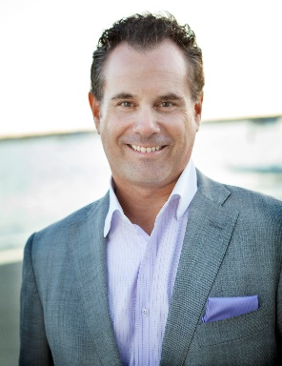
SUMMARY
A seasoned storyteller, whether reporting or anchoring. A team player and dedicated journalist with an affable nature and aggressive reporting style. A steward of the Fourth Estate, always seeking an angle of accountability. An excellent live reporter who likes to move around and use props and his surroundings to bring viewers into a story. Dedicated dad to two great boys, happy husband to an awesome wife. Doggy-dad.

Currently reporting and anchoring at WKRC in Cincinnati with a dedicated newsroom of journalists. Very involved in the community, hosting public events and assisting community organizations.

BROADCAST EXPERIENCE
WKRC-TV, Cincinnati Reporter / Fill-in Anchor 2019 – 2020
KTMF-TV, Missoula/Kalispell/Butte/Bozeman Main Anchor 2014 – 2017
KNTV-TV, San Francisco Reporter / Fill-in Anchor 1992 – 1995
WWMT-TV, Grand Rapids Reporter / Weekend Anchor 1989 – 1992
WAND-TV, Champaign Reporter / Weekend Anchor 1988 – 1989
KCEN-TV, Waco Reporter 1987 – 1988
KTVN-TV, Reno Reporter / Weather Talent 1986 – 1987

OTHER EXPERIENCE
Mobile Alert Software, Missoula, MT CEO 2018 – 2019
Ran company that designed school alert mobile apps.

Agency Revue, San Clemente, CA President 2012 – 2014
Hosted forums to align corporations with marketing agencies.

Luxury Marketing Council, Los Angeles, CA Chairman, Southwest US 2007 – 2012
Hosted events and consulted luxury brands to execute partnership marketing campaigns.

WinterMedia, Laguna Beach, CA President 2001 – 2007
Hosted and produced video news releases, satellite media tours, corporate videos.

Electronic Media Communications, Newport Beach, CA EVP 1995 – 2001
Responsible for the creative direction of the company’s public relations campaigns.

EDUCATION
San Diego State University: B.A., Broadcast Journalism. Minor, Political Science
The Poynter Institute – Ethics in Journalism

AWARDS
National Association of Broadcasters Investigative Journalism
Associated Press Investigative Journalism
Radio/TV News Directors Association Spot News

REFERENCES
Tim Geraghty News Director WKRC-TV Cincinnati 407-747-0146
Anthony Dorunda Producer WKRC-TV Cincinnati 607-372-2532
Jillian Parrish Assignments WKRC-TV Cincinnati 513-276-2367
TR Gormley Photographer WKRC-TV Cincinnati 513-200-9452

RESUME REEL
https://youtu.be/vIbjlV7SjxY

